Only use pre-packaged deli meat. Do not use deli meat sliced at a deli counter. Use high-quality, protein-rich ingredients with the latest expiration date. Also, please wash your hands thoroughly and wear gloves.

Step 1 | 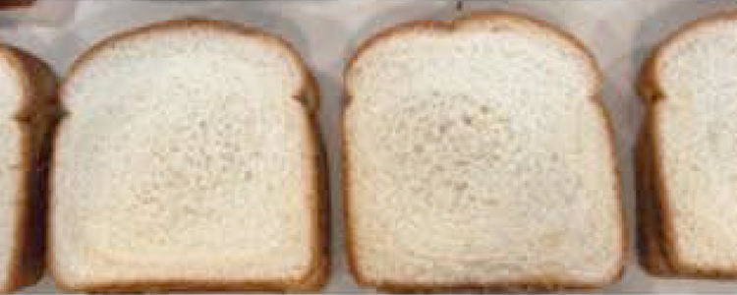 | Keep all ingredients refrigerated throughout the sandwich-making process.
Step 2 | 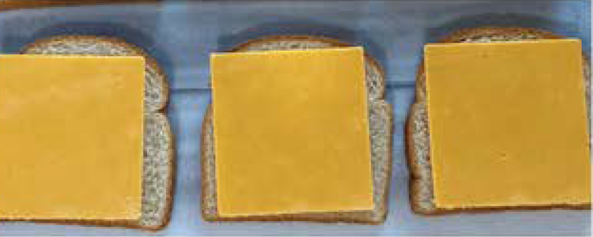 | Washing hands,wearing gloves and hair ties is REQUIRED. Lay out bread—no ends/heels.
Step 3 | 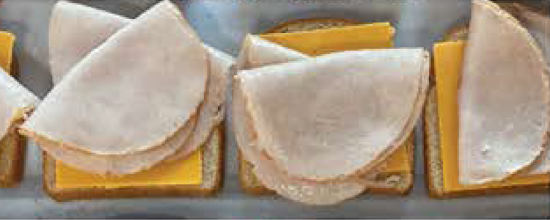 | Place one piece of cheese on EACH slice of bread. Every sandwich should have two pieces of cheese. No condiments should be used.
Step 4 | 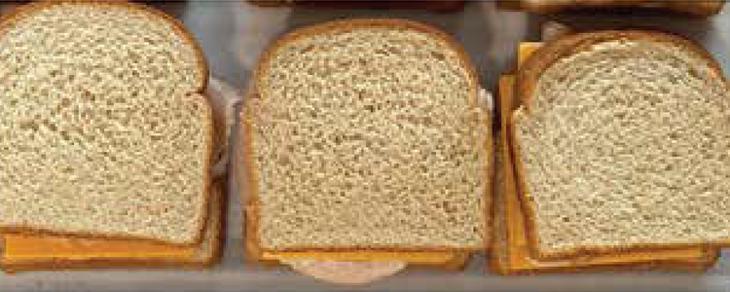 | Use 3 ounces/3 slices of high-quality turkey or ham on each sandwich—NO meat alternative allowed.
Step 5 | 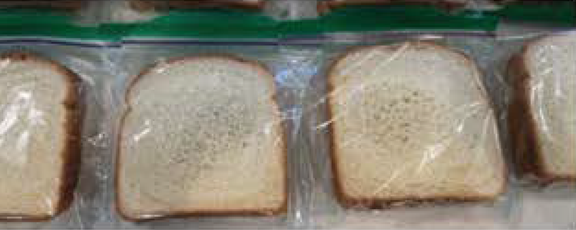 | Place each sandwich in an individual zip-lock sandwich bag. Press out excess air. Seal tightly.
Step 6 | 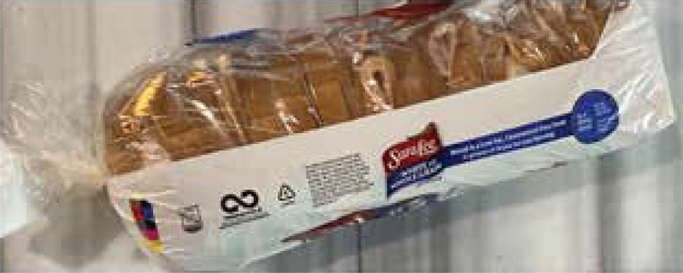 | Neatly place the zip-locked sandwiches into the loaf bag, press out excess air, and secure well with a twist tie—no knots or bands. Place the complete loaf bags in a refrigerator.

